逻辑门

用NOT, AND, OR表示其他逻辑门

A NAND B = NOT (A AND B)

A NOR B = NOT (A OR B)

A XOR B = (A OR B) AND NOT (A AND B)

A XNOR B = NOT (A OR B) AND NOT (A AND B)

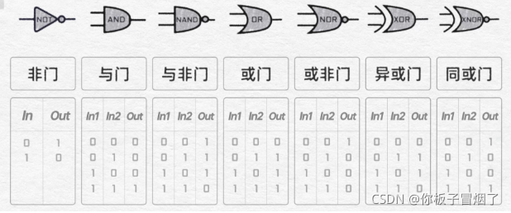

NOT

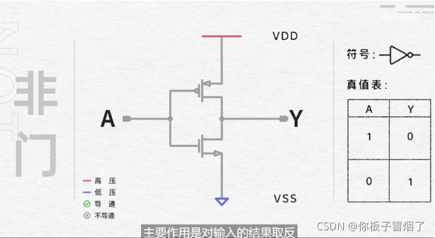

AND

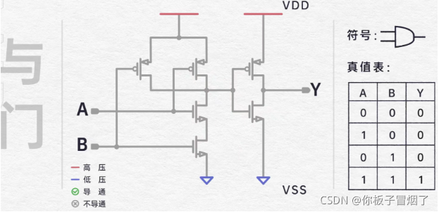

NAND

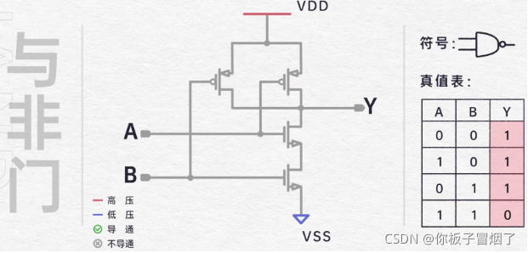

OR

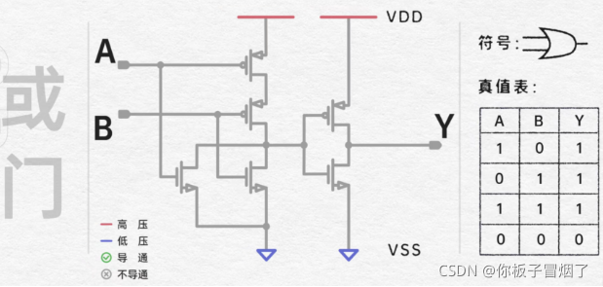

NOR

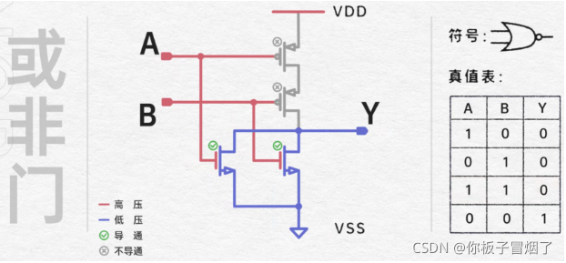

XOR

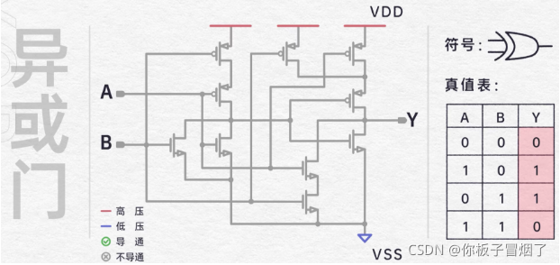

XNOR

